Question1. Write a python program to implement TSP (Travelling Salesman problem) using genetic algorithm.

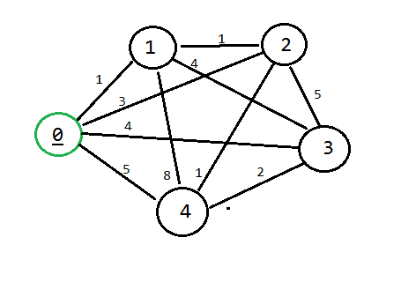

Question2. A Maze is given as N\*N binary matrix of blocks where source block is the upper left most block i.e., maze [0][0] and destination block is lower rightmost block i.e., maze[N-1][N-1]. A rat starts from source and has to reach the destination. The rat can move only in two directions: forward and down. In the maze matrix, 0 means the block is a dead end and 1 means the block can be used in the path from source to destination. Solve it by using DFS.

